CHA . . .
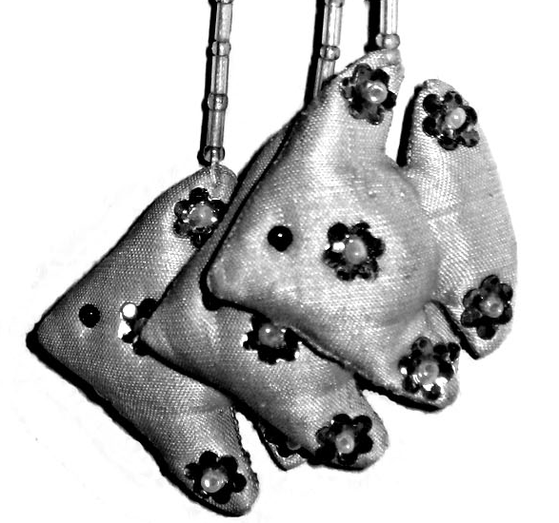
The Cambodian Handicraft Association for Landmine and Polio Disabled (CHA) is a local NGO set up in 2000 by a group of Khmer people. It produces a range of beautiful silk goods of exceptional quality, made by some remarkable Cambodian disabled people.
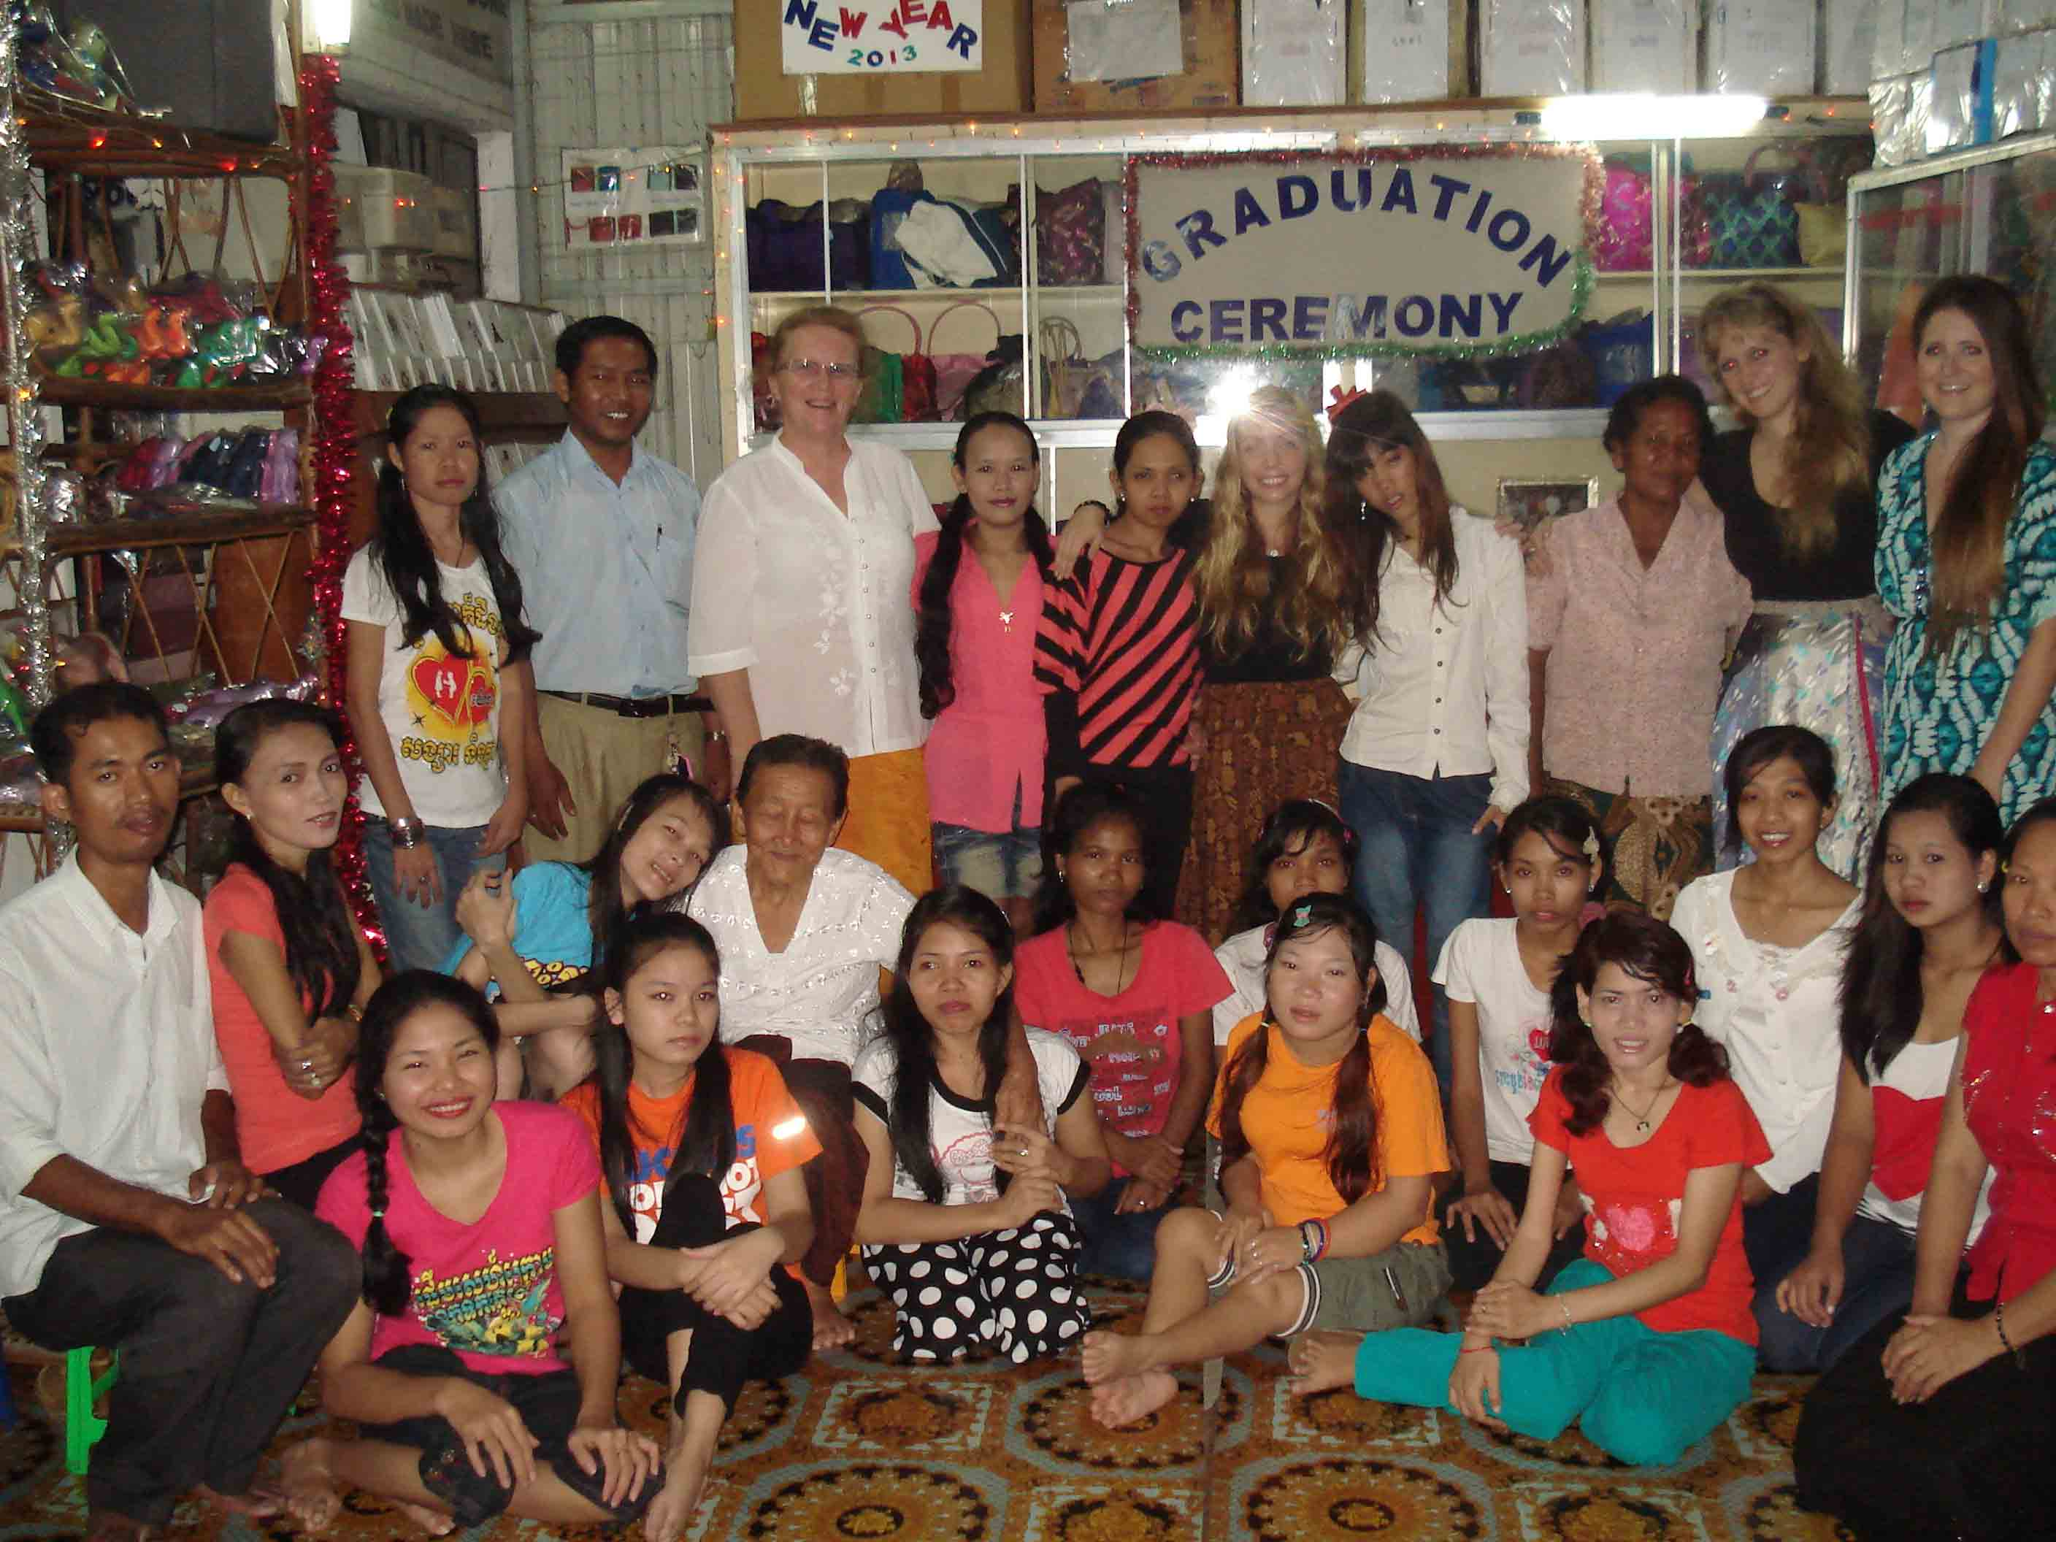

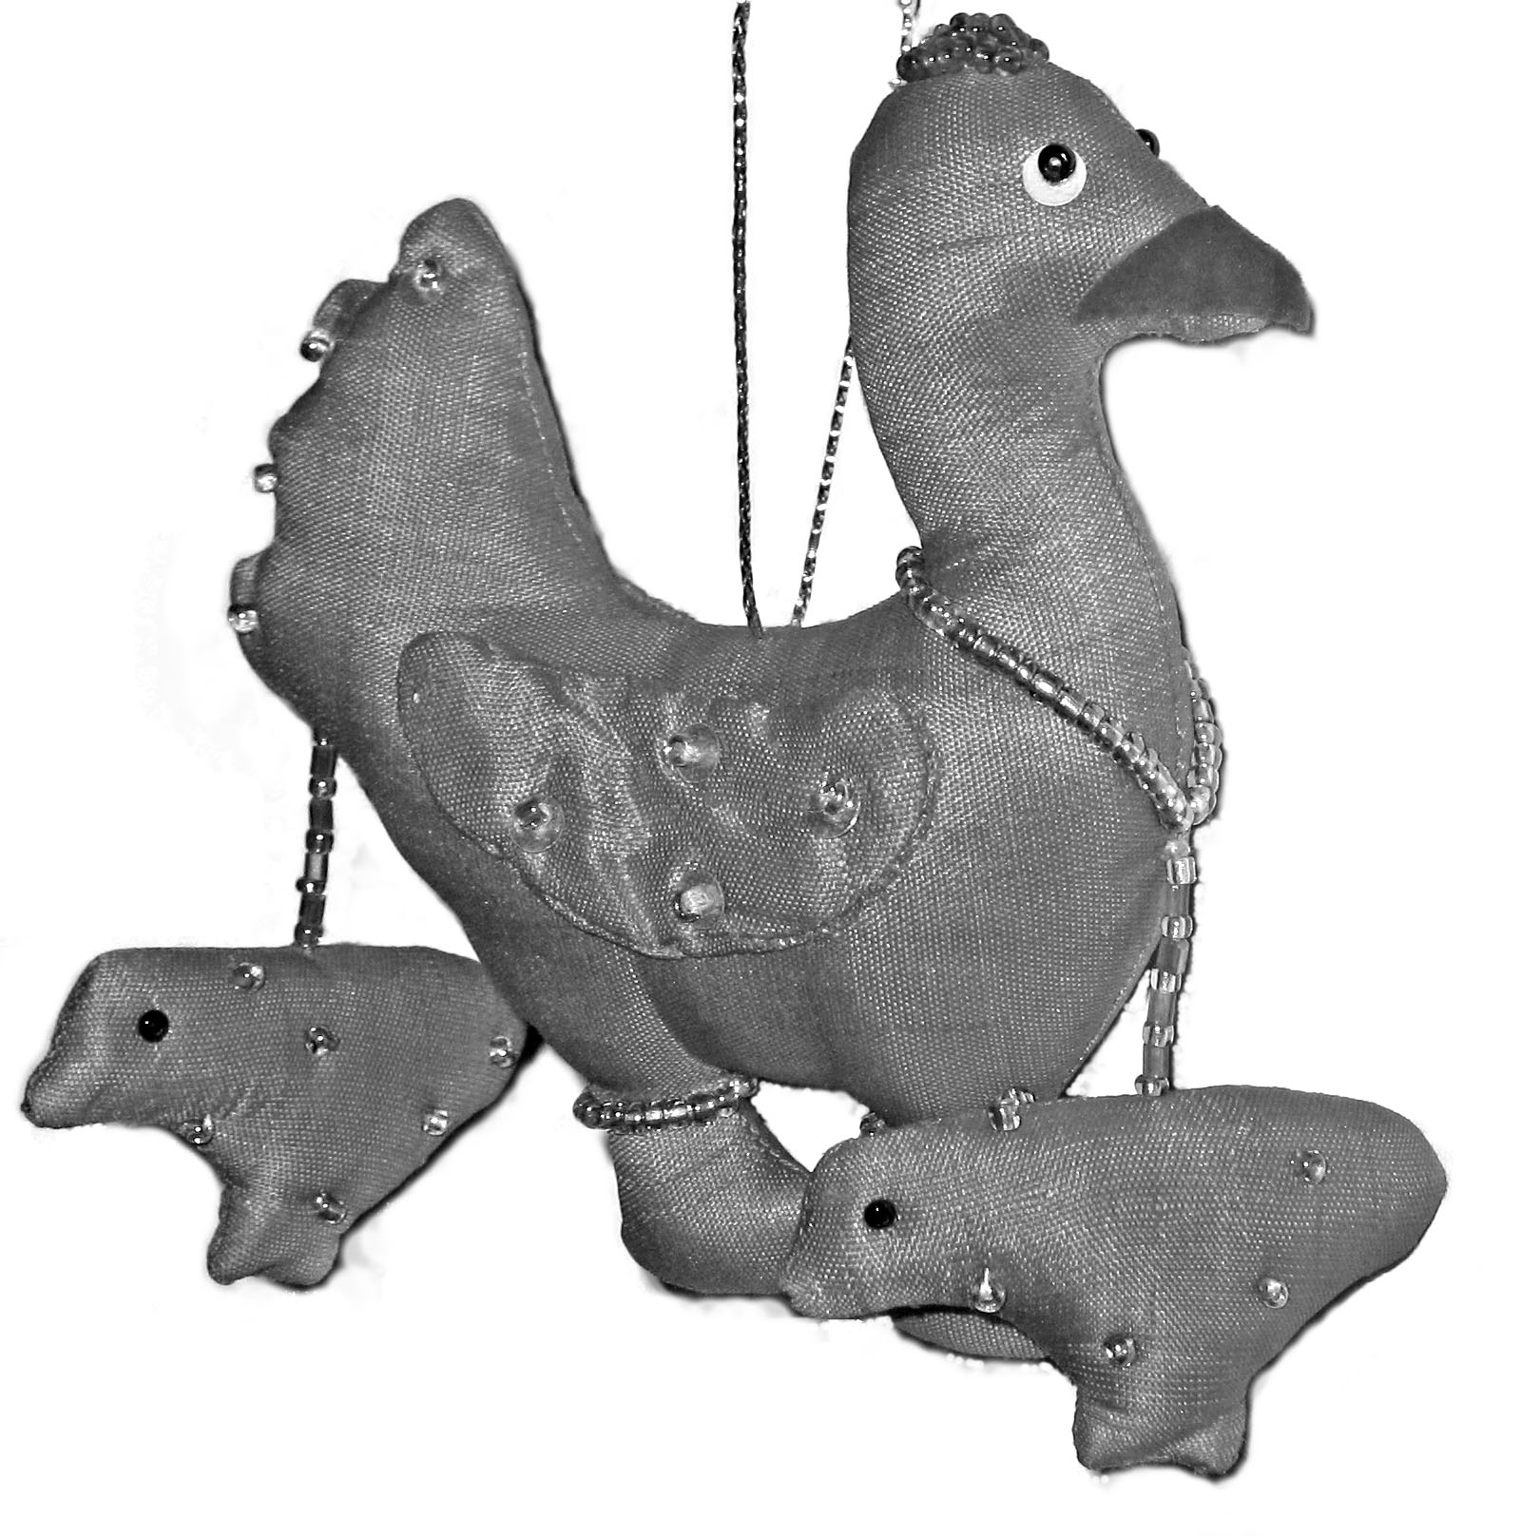
Cambodia currently has three active landmines for every Cambodian man, woman and child. Most of these are now in known areas, but the risk of death or maiming by these insidious weapons remains ever-present.
Polio is a devastating disease, leaving survivors with varying degrees of disability, from difficulty walking, to no use of their legs at all. Thankfully it is almost eradicated from Cambodia, but the legacy of disabled survivors will remain with Cambodia for many years to come.
There is no state support for the disabled in Cambodia, and as it is almost impossible to find work when disabled they are often seen as a burden on their families.
CHA provides a way out of this dependency and despair.
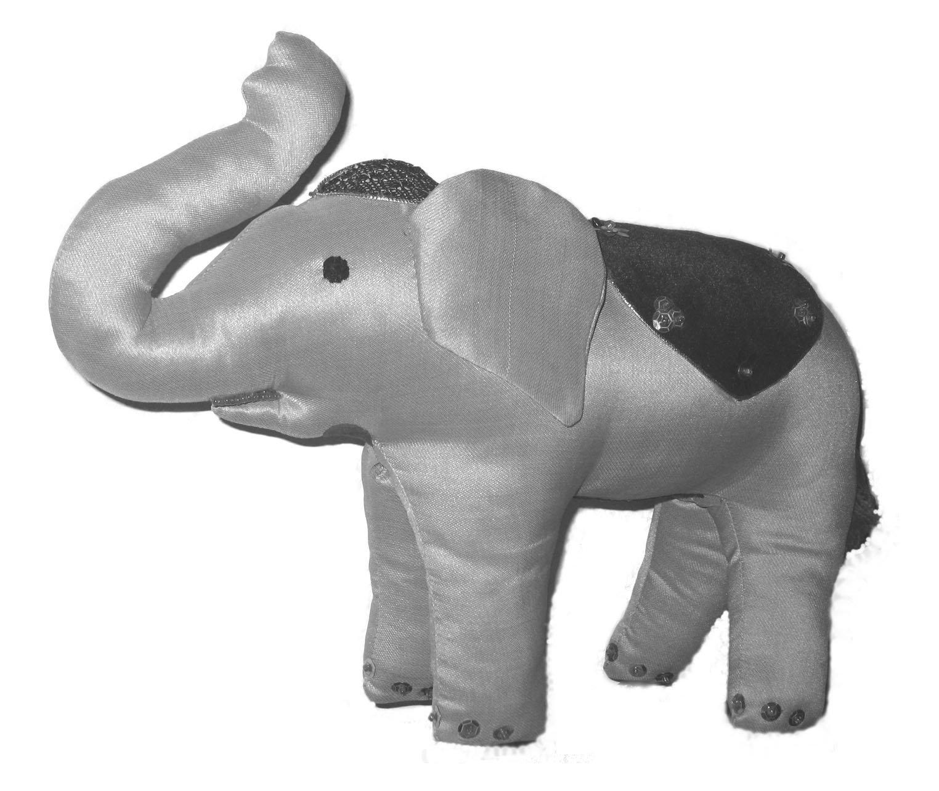
Each product is carefully made to the highest standards by disabled craftsmen and women. The CHA teaches new skills in handicrafts,, providing our trainees with the means to earn their own living and return to their communities.

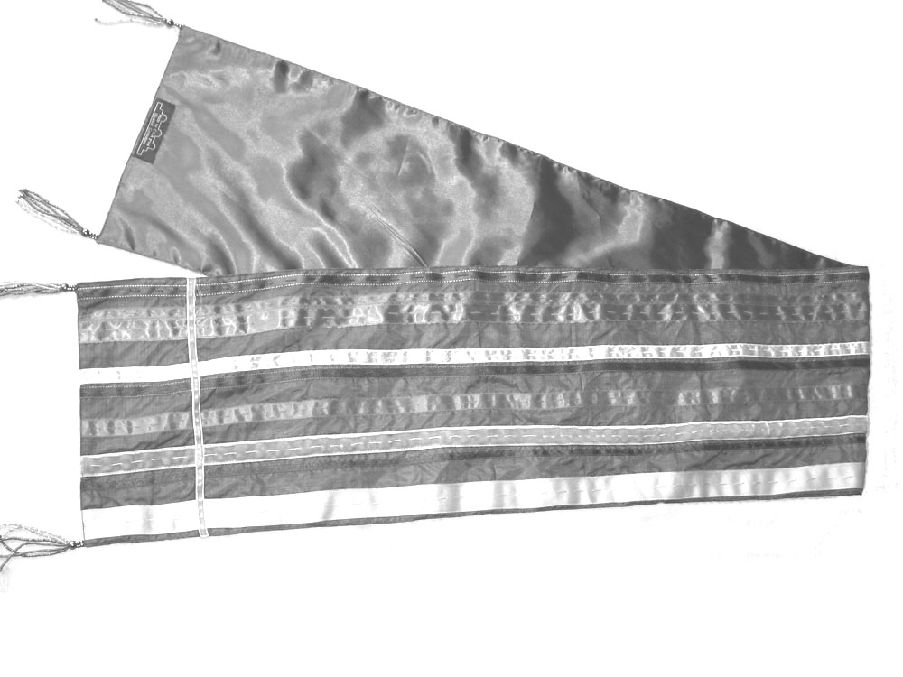
CHA sells a variety of beautiful handicrafts, all handmade by the disabled: gorgeous silk shawls and handbags, entrancing mobiles, purses and wallets, toys, clothes, cards . . . . . . . .
For a full range come and see for yourself!

Location . . .
The Phnom Penn workshop is almost opposite the entrance to the Tuol Sleng Museum, and is an excellent life affirming compliment to the experience of the museum.
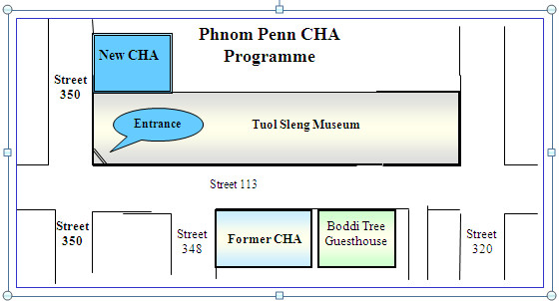
The Siem Reap program is situated on the way to Banteay Srei Temple.
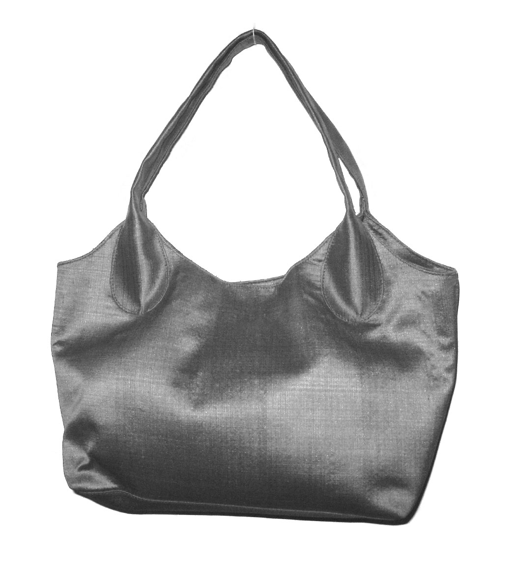
What CHA does . . .
CHA seeks to assist people disabled by landmines and polio reintegrate into society. We provide a home and a friendly environment for our trainees to learn handicraft skills preparing them for future employment.
We build the self-esteem of our disabled trainees, teaching them and the public that the disabled are, in fact, able.

So far CHA has enabled over 150 disabled to return to their communities with new skills and new hope.

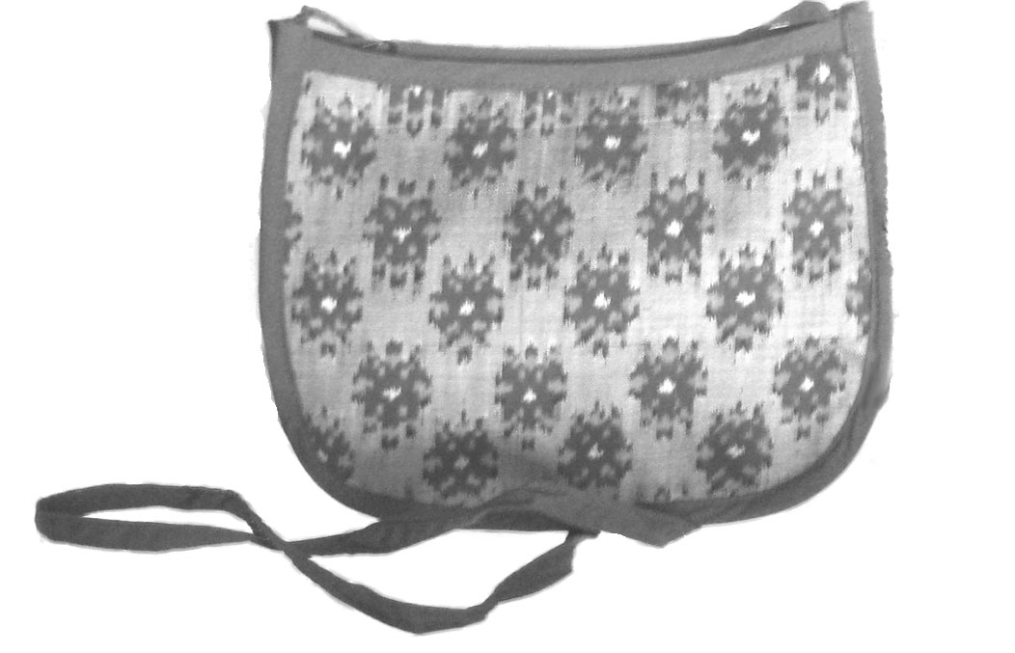
We fund these activities entirely through sales of our handicrafts without grants or aid. By buying one of our products you are directly contributing to the future of our disabled.

Our shops are open 7.30 am to 5.30 pm every day.
(Closed on major public holidays.)

Come and visit us !!
Details . . .
www.cha-cambodia.org
Website:

Email: wthanchashop@online.com.kh

Tel: (+ 855) 012 916 796 or
012.913 861
Address: Phnom Penh
P. O. Box 1396
No 1, Steet 350,
Sangkat, Boeung Keng Kang 3,
Khan Chamkar Morn,
Phnom Penh, Cambodia
Address: Siem Reap
Preah Dark Project,
Banteay Srei, Siem Reap
Cambodia
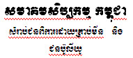
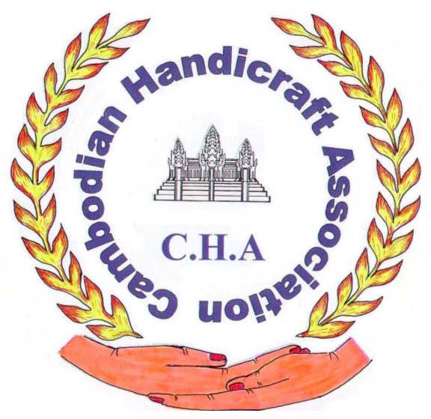

New Skills for a New Life

CHA is a local NGO allowing the disabled to work towards a brighter future.

Cambodian Traditional Silk
Handicrafts
Souvenirs
Cards
Tailoring Services
Exports

